The Maria de Villota Legacy was born with the objective of transmitting Young people and sportsmen and women the joy and the values that she represented, through a week of events, promoted by the CSD’s Young Sports Foundation, the Santander City Hall and the What Really Matters Foundation, helped by the patrons who assisted María.

From July 1-6, Santander, European Sports City, will held the “What Really Matters” Congress, a reflection day under the auspices of the Universidad Internacional Menéndez Pelayo, and sports street activities promoted by the CSD’s Young Sports Foundation, in collaboration with Federations, Clubs and the city’s Municipal Sports Institute.

Speakers
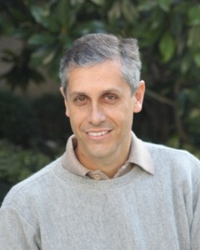

Jorge Font
Disabled sportsman, eight times water ski world champion.
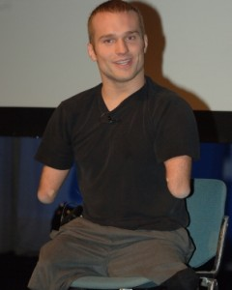

Kyle Maynard
Combat champion. He has climbed the Kilimanjaro. He was born limbless.
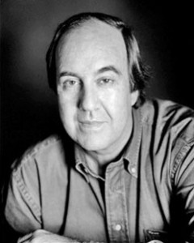

Nando Parrado
Survivor of the air crash in the Andes. He inspired the movie “Alive!”.
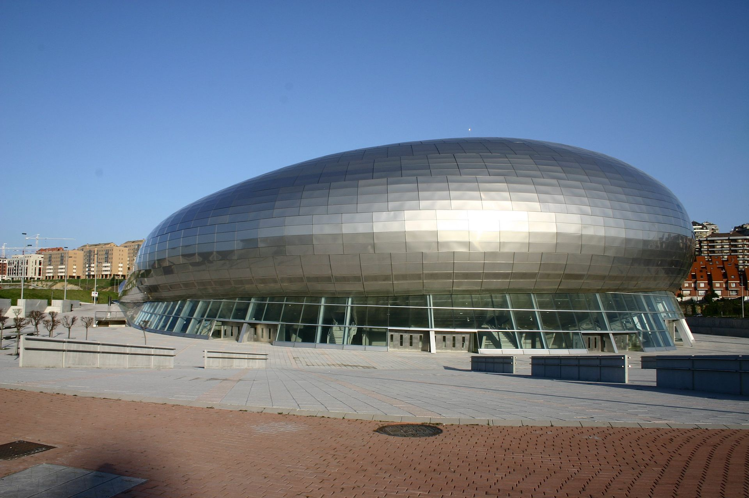

Program
09:00 – Opening of doors
10:00 – Inauguration ceremony
10:00 – Documentary María de Villota introduced by Mario Alonso Puig
11:15 – 1st Talk: Kyle Maynard
12:30 – 2nd Talk: Jorge Font
13:45 – Break
15:15 – 3rd Talk: Nando Parrado
16:30 – Closure

Support

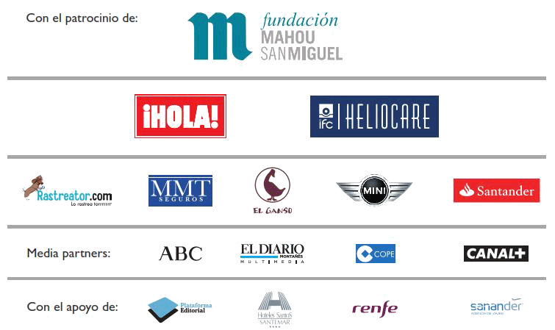

- Open Day “Values in Sports”
The "Values in Sports”Day will take place on July 2 at the Universidad Internacional Menéndez Pelayo in Santander (Spain) and will have the participation of Carlos Gracia, President of RFEDA, Dr. César Casado, Service Chief of the La Paz Hospital Plastic Surgery and Burn Unit, José Santos, F1 engineer, currently in the Porsche team of the Le Mans 24 Hours, and Gonzalo Silió, Psycho-pedagogue and trainer in "Skills for life” at the EDEX Foundation. Later on there will be a round-table conducted by Jiménez, Director of the CSD Young Sports Foundation and composed by Theresa Zabell, twice Olympic champion, Balba González Camino, ex pilot, José Santos, Luis Monzón, current Spain champion of rallies, who shared the wheel with María at the Daytona 24 Hours and Gonzalo Silió.
The seminar´s topic "Values in Sports”, will recall experiences and situations lived by different people who had contact with María.
- Sport events
With the involvement and support of the Foundation of the Superior Sports Council and the Santander City Hall, on July 3, 4, 5 and 6, the city will become a scenario of different sport events.
Sailing, karate, basketball, fencing, baseball, golf, rugby and running, and the celebration of a popular race, will be some of the activities sportspeople, young people and families may join in, thanks to the generous collaboration of the Ecomar Foundation, the Santander City Hall, Clubs, the Municipal Sports Institute and other Spanish and Cantabria Region sports federations.

