WHO ARE WE?

Delegations
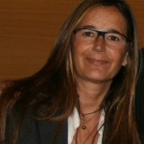Cristina de la Vega –Foundation Delegate in La Coruña (Spain)
“What really matters is becoming the change I want to see in the world.”
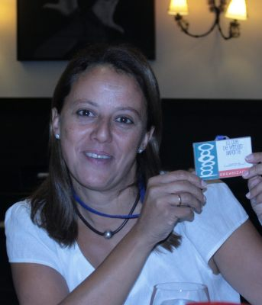Eugenia Blasco – Foundation Delegate in Seville (Spain)
“What really matters is knowing that when we leave this world, we will only carry the love and the happiness we have shared.”
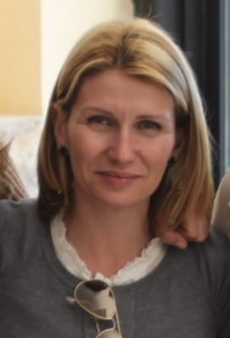Joana María Vives – Foundation Delegate in Palma (Spain)
“What really matters is knowing that important things are not mere things.”
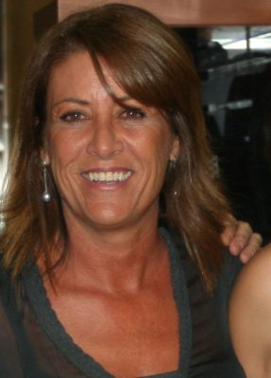Marta Villacampa – Foundation Delegate in Zaragoza (Spain)
“What really matters is making others happy.”
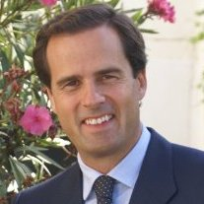Rafael Sáenz de Santa María – Foundation Delegate in Bilbao (Spain)
“What really matter is helping and making others happy.”
Celia Martínez – Foundation Delegate in Barcelona (Spain)
“What really matters is giving value to what really matters.”

